# Communications resources to help you talk to families about Free Kinder

For sessional   
services

# 

# Contents

Introduction 3

Sample email to parents/carers 4

Free Kinder factsheet for parents 5

Talking points to assist with your conversations with families 6

Website/newsletter/platform content 7

Suggested social media content 8

Further resources 10

# Introduction

With Free Kinder available across Victoria, you may find more families are getting in touch to ask whether your kindergarten programs are part of the Free Kinder initiative.

**Offering Free Kinder**

It is essential that families understand that a free program is available for children enrolled in funded Three- and Four-Year-Old Kindergarten and Pre-Prep programs.

Where additional program hours are offered over and above the free program, services must make it clear to families that they can receive a free program and that any hours above that are optional and not a mandatory requirement to receiving a free program.

Families that choose to access additional hours should not be prioritised over other families.

**Communications resources**

This communications pack includes information and sample text you can use to promote Free Kinder at your service:

* a template letter to families that have children enrolled in a Free Kinder program
* a factsheet, ‘Advice for families: Free Kinder in sessional services’, which is also available for download along with translated versions.
* talking points to assist with conversations with families
* content you can use on your website/newsletter/social media platform
* social media materials, email banners and posters
* further resources, including links to translated materials.

**Supporting culturally and linguistically diverse (CALD) families**

Translated kindergarten resources are available to support families in the enrolment process. You can order complimentary printed copies online at [Kinder (finsbury.com.au)](https://shout.finsbury.com.au/kinder/) for use in your community.

More information about supporting CALD families to participate in kindergarten is available on our [website](https://www.vic.gov.au/supporting-cald-families-engage-kindergarten), including translated resources and videos and interpreter services.

If you have any further questions, you can also contact your [Early Childhood Improvement Branch](https://www.vic.gov.au/contact-early-childhood-improvement-branch)

# Sample email to parents/carers

Dear Families

**Free Kinder at [INSERT SERVICE NAME]**

The Victorian Government provides Free Kinder funding to support children access a high-quality kindergarten program in the 2 years before they start school.

Free Kinder provides families with a free program. At our service this means:

* a free Three-Year-Old Kindergarten program of [INSERT HOURS] hours, and
* a free 15 hour Four-Year-Old Kindergarten program [OR FOR PRE-PREP – a free [INSERT HOURS] Pre-Prep program

[ONLY INCLUDE IF APPLICABLE] At our service we offer extra program hours for a fee. These hours are optional. If you do not want extra hours beyond the funded kindergarten program, your child can still attend the 15-hour program [or Pre-Prep program] free of charge.

We offer an extra [INSERT HOURS] for our [Three/Four]-Year-Old Kindergarten program. The fee for the extra hours is $[ENTER FEE].

**Free Kinder eligibility**

Your child can access one year of Free Kinder in a Three-Year-Old Kindergarten program and one year in a Four-Year-Old Kindergarten or Pre-Prep program.

Your child can only access a Victorian Government funded kindergarten place and receive Free Kinder funding in one service at a time. Each year families must sign a form to confirm where their child is receiving their funded kindergarten program. This is to make sure funding for your child goes to the right service.

If you are not sure if you have signed this form, please let us know.

If you have any questions, please feel free to reach out at: [ADD EMAIL ADDRESS FOR ENQUIRIES].

Kind regards,

[INSERT NAME AND SIGNATURE BLOCK. SEE EMAIL BANNERS ON PAGE 5.]

# Free Kinder factsheet for parents

A Free Kinder factsheet is available for services to share with their families. This provides detailed information on what Free Kinder means for families accessing a funded kindergarten program in a sessional service.

The [factsheet](https://www.education.vic.gov.au/Documents/childhood/three-year-old-kinder/free_kinder_sessional_communication_pack_2025.docx) can be accessed on the [Communicating About Kinder to your Community page](https://www.vic.gov.au/communicating-about-kindergarten-to-your-community).

[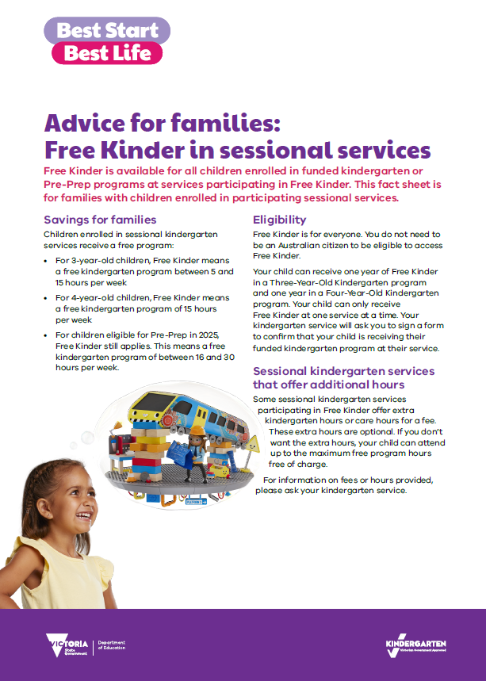](https://www.education.vic.gov.au/Documents/childhood/three-year-old-kinder/free_kinder_sessional_communication_pack_2025.docx)

# Talking points to assist with your conversations with families

* Free Kinder is available for Three- and Four-Year-Old Kindergarten or Pre-Prep programs at participating services in Victoria.
* Free Kinder provides families with a free program. At our service this means:
* a free Three-Year-Old Kindergarten program of [INSERT HOURS] hours, and
* a free 15 hour Four-Year-Old Kindergarten program / a free [INSERT HOURS BETWEEN 16-30 HOURS] hour Pre-Prep Kindergarten program.
* Free Kinder helps all Victorian children access 2years of a high-quality kinder program before they start school.
* In Victoria, families with children born between January and April can choose which year to start Three-Year-Old Kindergarten. These children can start in the same year they turn three, or in the year they turn 4years of age. If your child turns 3between January and April, they may not be able to attend until they have turned3. You can enter your child’s birthdate in the [Starting Age Calculator](https://www.vic.gov.au/give-your-child-the-best-start-in-life#when-to-start-three--and-four--year-old-kindergarten) to find out what year they can start Three and Four-Year-Old Kindergarten or Pre-Prep.
* Free Kinder is for everyone. You do not need to be an Australian citizen to be eligible to receive Free Kinder.
* [IF APPLICABLE] At our service we offer extra program hours for a fee. These hours are optional. If you do not want any extra hours, your child can still attend the [INSERT HOURS – 15 for Four-Year-Old Kindergarten and 16-30 for Pre-Prep] program free of charge. We offer an extra [INSERT HOURS] for our [Three/Four]-Year-Old Kindergarten program. The fee for the extra hours is $[ENTER FEE]

# Website/newsletter/platform content

[INSERT SERVICE] is a proud provider of the Victorian Government’s Free Kinder initiative.

This means you will receive a free Three-or Four-Year-Old Kindergarten program of 15 hours, or a Prep-Prep program of [INSERT HOURS].

Free Kinder helps all Victorian children access 2years of a high-quality kindergarten program before they start school. Enrolling your child in a kindergarten program for 2years can help develop their skills so they do well in life and school.

Free Kinder is for everyone. You do not need to be an Australian citizen to receive Free Kinder.

Free Kinder is available if your child attends either our Three-Year-Old kindergarten program [between 5 to 15] hours per week (that is, [INSERT DAYS] days per week), or our Four-Year-Old Kinder program for [15] hours per week ([INSERT DAYS] days per week) or [FOR PRE-PREP: our Pre-Prep program for [16-30] hours per week ([INSERT DAYS] days per week)].

[IF APPLICABLE] If you choose to enrol your child in more than 15 hours [Pre-Prep: 16-30 hours], fees will be charged for the extra hours only (above 15 hours [Pre-Prep: 16-30 hours]).

Remember, you cannot enrol your child in more than one funded kindergarten program at any one time.

For more information, ask our staff or visit [vic.gov.au/kinder](http://www.vic.gov.au/kinder).

# Suggested social media content

Here are some sample email banners and social media posts that can be used across your own social channels to help promote the availability of Free Kinder at your service.

## Social media images

Right click and save an image to use for your social media posts.

## 

## Social media post copy

**Sample posts (Facebook):**

***[INSERT SERVICE NAME]*** *is a proud provider of the Victorian Government’s Free Kinder Initiative. This means you can receive a free program when your child is enrolled in the funded kindergarten program at our service. Contact us today to find out how to enrol.* [*vic.gov.au/kinder*](https://www.education.vic.gov.au/childhood/Pages/questions-three-year-old-kinder.aspx)

*90% of a child’s brain develops by the time they turn 5 – the benefits of going to kinder for two years before school can last a lifetime. That’s why Free Kinder is available at* ***[INSERT SERVICE NAME]****. Contact us today to find out how to enrol.*

**Sample post:**

*Free Kinder is available to 3 and 4-year-old children enrolled in a kindergarten program at* ***[INSERT SERVICE NAME]****.* To find out about what Free Kinder covers, talk to us or visit [vic.gov.au/kinder](https://findakinder.educationapps.vic.gov.au/).

**Sample post:**

*Have you heard about Free Kinder for 3 and 4-year-old children? It’s available now at* ***[INSERT SERVICE NAME]****. Two years of quality kindergarten programs before school gives children the best start in life. Visit* [*vic.gov.au/kinder*](http://www.vic.gov.au/kinder)*.*

**Sample post:**

*Kindergarten is an important step for children. Research shows that two years of kindergarten before school are better than one. Free Kinder is available at* ***[INSERT SERVICE NAME]****! Talk to us about how to enrol.*

**Sample post:**

*To dream big, our kids need the best start in life. That’s why children across Victoria now have access to Free Kinder, including at* ***[INSERT SERVICE NAME]****. To find out about more, talk to us or visit* [*vic.gov.au/kinder*](http://www.vic.gov.au/kinder)*.*

## Email banners

Right click and save an image to use as an email banner. Please ensure you hyperlink your email banner to: [vic.gov.au/kinder](https://www.vic.gov.au/kinder)

## Poster

Download and print a parent facing poster for display in settings where parents and carers frequent at your centre.

[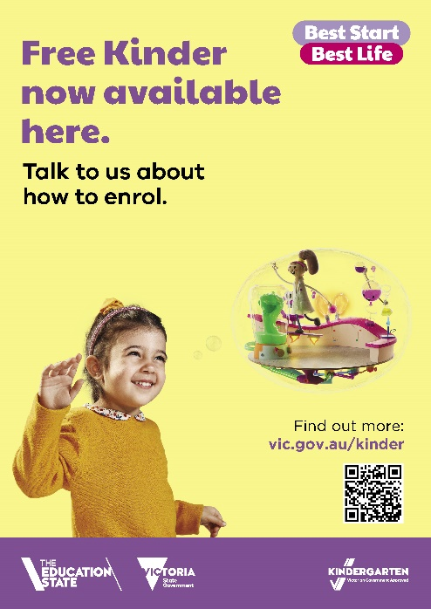](https://www.education.vic.gov.au/Documents/childhood/three-year-old-kinder/Free-Kinder-now-available-here%E2%80%93enrol-(poster).pdf)

Please tag the Department of Education so we can ‘like’ your posts.

* [[DE LinkedIn](https://www.linkedin.com/company/department-of-education/?originalSubdomain=au)](https://au.linkedin.com/company/department-of-education)
* [DE on X](https://twitter.com/VicGovDE?ref_src=twsrc%5Egoogle%7Ctwcamp%5Eserp%7Ctwgr%5Eauthor)
* [Early Childhood Victoria Instagram](https://www.instagram.com/earlychildhoodvic/)

We also suggest linking to [vic.gov.au/kinder](https://www.vic.gov.au/kinder) so your audience can find out more information.

# Further resources

The below resources can also be used in your communications with families.

|  |  |
| --- | --- |
| Resource | Details |
| [[**Online kindergarten starting age calculator**](https://www.vic.gov.au/give-your-child-the-best-start-in-life#when-to-start-three-and-four-year-old-kindergarten)](https://www.vic.gov.au/give-your-child-the-best-start-in-life#when-to-start-three--and-four--year-old-kindergarten) | To help families find out what year their child can start Three- and Four-Year-Old Kindergarten. |
| [[**Kinder Tick**](https://www.vic.gov.au/kinder-tick)](https://www.vic.gov.au/kinder-tick) **program** | The Kinder Tick helps Victorian families find a funded kindergarten program. [Order Kinder Tick materials,](http://shout.finsbury.com.au/kinder/) including signage for your service. |
| [**Order printed materials**](https://shout.finsbury.com.au/uStore/login.aspx?StoreID=112) | [[Services can order printed materials](https://www.vic.gov.au/early-start-kindergarten),](https://shout.finsbury.com.au/uStore/login.aspx?StoreID=112) including posters. These materials are paid for by DET and printed and delivered to your service. |
| [**Translated resources**](https://www.vic.gov.au/kinder/translations) | Available in Arabic, Assyrian, Bengali, Burmese, Chinese (Simplified), Chinese (Traditional), Dari, Dinka, Farsi, Greek, Gujarati, Hakha Chin, Hazaragi, Hindi, Indonesian, Italian, Karen, Khmer, Korean, Nepali, Oromo, Punjabi, Sinhalese, Somali, Spanish, Swahili, Tamil, Telugu, Thai, Turkish, Urdu and Vietnamese. |
| [**Communicating about kindergarten to your community webpage**](https://www.vic.gov.au/communicating-about-kindergarten-to-your-community) | Resources for services and providers to communicate with families about kindergarten and its benefits:   * additional resources to help welcome all families to your service * email signature image * social media tiles * brochures * posters (including editable versions), factsheets, and postcards * infographics to show the benefits of two years of kindergarten for children |